Sequence Diagram - User Registration, Login and MFA Verification
Australian Clinical Labs Online Reporting System
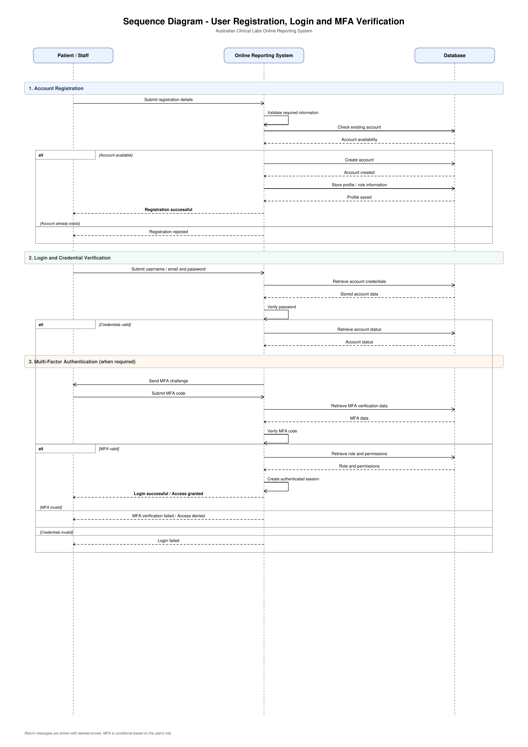
Figure: Account registration, login, MFA verification, role retrieval and access outcome.

1. Account Registration: Patient/Staff submits registration details to the system. The system validates the information and checks the database for an existing account. If the account does not already exist, a new account and profile information are stored.
2. Registration Confirmation: After the account is successfully created, the system sends a registration confirmation to the Patient/Staff. If the account already exists, the registration request is rejected.
3. Login Request: Patient/Staff submits a username or email address and password. The system retrieves the relevant account information from the database and verifies the login credentials.
4. Credential Verification: If the credentials are invalid, the system rejects the login request. If they are valid, the system proceeds to the next authentication stage.
5. MFA Verification: For users who require Multi-Factor Authentication, the system sends an MFA challenge. The user submits the MFA code, which is then verified by the system.
6. Role and Permission Verification: After successful MFA verification, the system retrieves the user's role and permissions from the database to determine the appropriate level of access.
7. Access Result: If all authentication checks are successful, the system creates an authenticated session and grants access. If the MFA verification fails, access is denied.

